Model(s): Channel Frame, Transition Frames
Prepare for Installation
- Locate the packing slip(s) and shop drawings.
- Verify that all products listed on the packing slip are included in the package.
- Check the products for damage. If products are damaged, report a freight claim immediately and leave the products in their packaging. If you sign for products without reporting damage you waive your right to a freight claim and will be responsible for their replacement cost.
- Read the instructions thoroughly before beginning installation.
Install the Frame
A flat recess and accurately installed frames are critical to the overall performance of the mat / grate. Utilize a self-leveling compound (provide by others) if necessary to ensure a level recess,
- Determine the correct depth of the recess. The outside of the frame must be flush with the finished floor surface. Make the recess the appropriate depth and slightly longer and wider than the frames to allow room to maneuver.
- Position the frame members in the opening, cut the frames to fit the opening.
- Frames are sent with drilled and countersink 1/4” diameter holes, mark and drill 1/4” diameter holes in the floor for the anchors.
- Line the frame members up with the holes and securely fasten the frame to the floor with the provided anchors.
- Verify the frame to make sure that it is plumb, that corner conditions are joined at the correct angles, and that it is at the correct height. Also, check the measurements of the frame against the shop drawings in several locations to make sure that the sizes are correct. Utilize a self-leveling compound (by others) if necessary to ensure a level recess. The floor must be flat and level with 1/8 inch over 10 feet to ensure proper installation.
Trim the Mat to Fit Opening
- Lay mat section(s) in the opening, the carpet strips must be perpendicular to traffic direction.
- The mats should fit snug to the top and left side of the opening.
- Trim the bottom and left side of the mats, the mat should fit snug to the frame.
Prepare the Mat for Installation
- Secure the mat retainers to each mat section. Each section will have at a minimum 4 retainers, one for each corner. Place the retainers approximately 2 rows in from the side and 5 sets of pegs from the bottom
Figure 2, MAXgrid™ Retainer
Figure 1, MAXtread™ Retainer
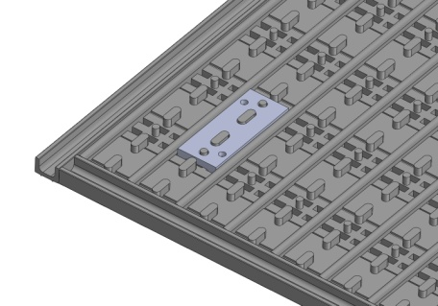
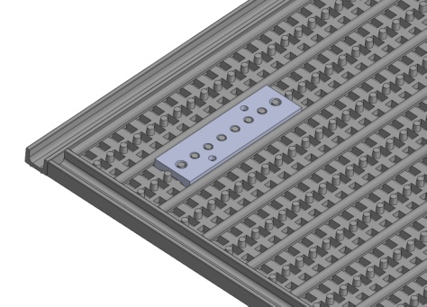
Install the Mat
- Clean the recess thoroughly. Note that debris will cause irregularities in the recess that may cause the mat to rock or create a tripping hazard.
- Set the trimmed mat(s) into the recess.
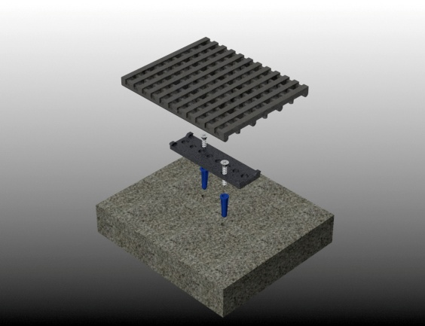
- Using the mat retainer holes as a guide, drill holes for the mat retainers; drill directly through the mat sections and retainer hole.
- Lift the mast sections and vacuum any dust.
- Hammer the blue screw sleeves into the holes.
- Replace the mat sections
- Drive the screws directly through the mat sections and retainers into the sleeves using a torque meter screw driver.
- Save the installation and maintenance instructions and include them with the closeout documentation for the owner and maintenance personnel.
maintenance
Continued maintenance is critical to the long-term safety and performance of the mat. Remove the mat and clean the recess periodically to prevent the surface from becoming uneven. Debris build up within the recess could lead to deflection in the grate and may possibly cause tripping hazards.
The type and schedule of maintenance of your grate or mat will depend upon location and amount of traffic. See the outline below for cleaning instructions for the variety of tread insert materials.
- A good heavy-duty vacuum cleaner with a rotating brush is the most effective way to routinely clean the carpet in your entrance grate or mat. By vibrating the fibers, this type of vacuum not only cleans the surface of the carpet, but also removes soil that is imbedded into the pile. The rotating brush aids in keeping the pile upright for longer lasting beauty.
- The heaviest traffic areas should be vacuumed daily and the light traffic areas as infrequently as weekly.
- Carpet should be deep cleaned with a hot water extraction cleaner once per month or when vacuuming will no longer remove the soil. This may be monthly, quarterly, or longer, depending
upon soil and traffic conditions.
- Inspect the grate or mat regularly for spots and stains, to reduce the possibility of them becoming permanent.
- Removing Spots
  - If the spot is semi-solid, scrape with a spoon or spatula and then blot with a damp sponge. Work from the edge of the spot to the center. This will keep the stain from spreading. If this procedure does not work, use a spot remover.
  - We recommend a dry system because it reduces solid build-up won’t leave floors wet and slippery, and there is no risk in damaging the carpet from dye bleeding. For most spills such as coffee, tea, pet stains, etc., a dry soil extractor works best.
  - Wet cleaning methods, including aerosols, foams, hot water extraction, or shampoo will work, but sometimes they leave sticky detergent residue that will accelerate soil build-up.
  - For oily stains such as tar, grease, paint, etc., a non-flammable dry cleaning solvent works best. Be extremely careful when using dry cleaning solvent. Take care to check for color fastness before cleaning the entire surface. Put a few drops of stain remover in an inconspicuous area and press the area with a clean cloth for ten seconds. If the color fades or changes, discontinue use.
Follow the tread maintenance instructions to ensure the long life of the tread. Contact your representative or Babcock-Davis for information on replacing damaged treads.

