January 1, 2019
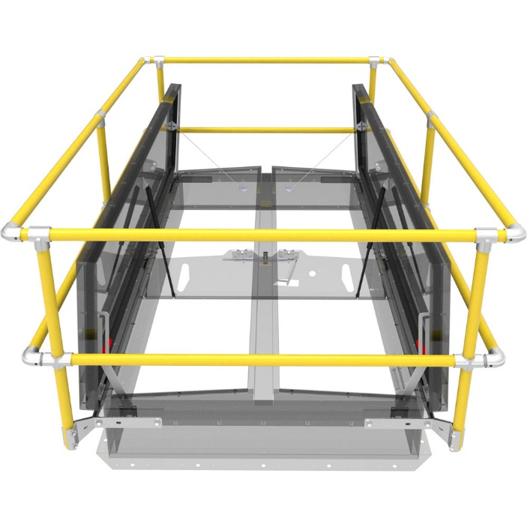
RE: Smoke Vent Safety Railing Product Change Notice

Babcock-Davis announces that powder coat safety yellow is now standard on all Smoke Vent Safety Railings.

Features
  - Aluminum rail and gate construction
  - Light weight design allows for easier and faster installation
  - Meets OSHA 29 CFR 1926.502
  - Available in standard and custom sizes, fits all brands of roof hatches that have a counterflash
  - Non-penetrating attachment to the hatch via the counterflash
  - Five (5) year warranty
Specifications
  - Rails / Posts: Aluminum pipe, 1-1/4 inch (31 mm), schedule 40, 6061 T6 alloy
  - Fittings: Aluminum alloy 5052-H32
  - Gate: Aluminum pipe, 1-1/4 inch (31 mm), schedule 40, 6061 T6 alloy
  - Mounting brackets: 3/16 inch steel, zinc plated

The new powder coat safety yellow aluminum safety rails will begin shipping January 1, 2019. Please contact us at 1.888.412.3726 should you have any questions or concerns. We appreciate the opportunity to service you.

