Model(s): NT, ET

Overview
Access Doors are designed and built for years of convenient and easy access to mechanical areas in commercial buildings.
The following is a general instruction for installing, operating and maintaining Architectural and Renovation Doors. These are recommended general guidelines only. Locally accepted practices and procedures should be followed to ensure the ultimate durability of access door installed into the various different types of construction.
Installation
Wall or ceiling opening is door size plus 1/4 inch. Example: 12” X 12” door, opening should be 12-1/4” X 12-1/4”.

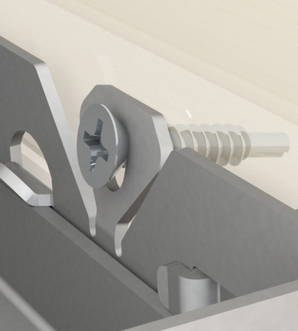
- Place the door into the opening. Flange should seat firmly against wall/ceiling surface.
- With door in open position, provide anchor attachment through Easy Install Tabs.
  - On sizes 24” X 24” and smaller, wall framing required on hinge side and latch side only.
  - On sizes larger than 24” x 24”, wall framing required on all 4 sides.
Figure 1
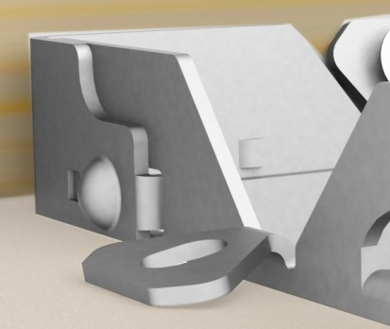
  - Secure hinge side first, then square up latch side and secure.
  - With remaining two sides, secure with anchor (by others) through hole in Easy Install Tabs (Figure 1), or fold over to secure to sheetrock (Figure 2).
  - Drywall bead door will require additional tape and mud to complete installation
Figure 2

Operation
Access doors are designed and built for years of dependable wall and ceiling access. Our access doors come standard with white baked on powder coat finish that offers the best corrosion protection in the industry.
The basic components for door operation include latching and locking mechanism and the button snap hinges:
- Latch: Screw driver operated cam latch for easy access
- Button snap hinge: Quickly and easily remove doors using the finger operated button snap hinges (Figure 3).
Figure 3
Maintenance
- Access doors should be manually operated once a year to check performance.
- Lubricate moving parts such as hinges and latches with a silicone spray lube as required to maintain a smooth opening and closing of the door. Do not over grease. Do not use regular lubricating oil as it can attract dust and grit.
- Non-moving parts can be cleaned with a mild soap or dishwashing detergent and water solution.
- Gaskets can be cleaned with a clean, damp, lint-free cloth. Do not apply mineral oils, vinyl dressings, or other lubricants to the gasket as they can cause the gasket to break down over time.
- If any questions arise during the operation or maintenance of the products, please feel free to call for technical support.

