Lume-A-Lite™ NYC Compliant Running Man Signs
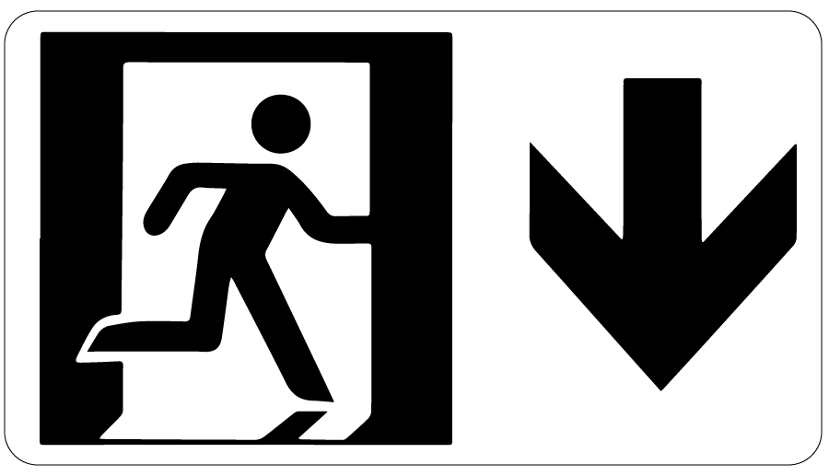
INSTALLATION, OPERATION + MAINTENANCE MANUAL
Model(s): BEM-SRAU, BEM-SREF, BEM-SREA, BEM-SREL, BEM-SRE, BEM-SNE

Table of Contents

Table of Contents
General Description 3
Installation 4
Operation 5
Maintenance 6
Standard Warranty 7
Factory Assistance 8

Copyright
2019 by Babcock-Davis. All rights reserved.

This document contains proprietary information. No part of this document may be reproduced without the prior written consent of Babcock-Davis.

Note
The information in this document is subject to change without notice.

General Safety Precautions
Improper selection, installation, or use can cause personal injury or property damage. It is solely the responsibility of the user, through its own analysis to select products suitable for their specific application requirements, ensure they are properly maintained, and limit their use to its intended purpose.

Follow proper local, state and federal regulations for proper installation and operation requirements.

General Description
Photoluminescent egress path marking systems are an important life safety requirement in current building codes. These systems allow for the safe and quick evacuation of buildings in the case of an emergency. They provide a routing system that is not dependent on electrical power that can easily be followed in dark and smoke-filled exit pathways.
The following is a general instruction for installing, operating and maintaining egress path marking systems. These are general guidelines only.
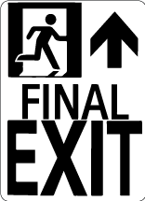
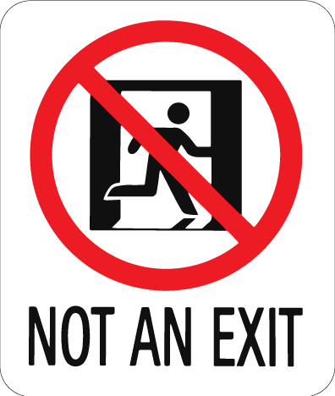
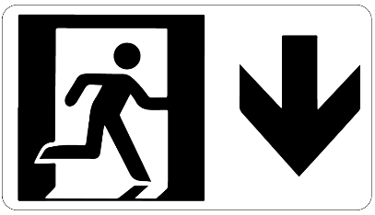
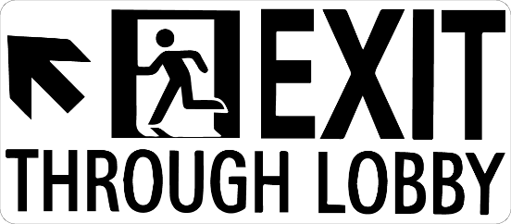
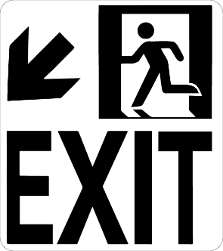
Preparation

Installation
Please read the complete instructions carefully before beginning any work.
- The temperature of the product being installed and the surface it is being installed on must be at least 60 degrees.
- Surfaces must be clean, smooth and non-porous.
Note: These are finished products and need to be stored in a clean and dry location. Adhesive has a shelf life of up to nine months from the date of shipment.
Installation
NYC compliant running man signs shall be placed on doors through which occupants must pass to complete the exit path. The sign shall be mounted on the door, centered horizontally, with the top of the symbol not higher than 18 inches above the finished floor (figure 1). The running man symbol must be orientated so that it faces towards the direction of egress. “Not Exit” (BEM-SNE) signs may also be required to be placed on doors in the exit path that are not to be used as an exit. Specific signs may also be required in the exit pathway on walls to help with guidance, check local codes for requirements.
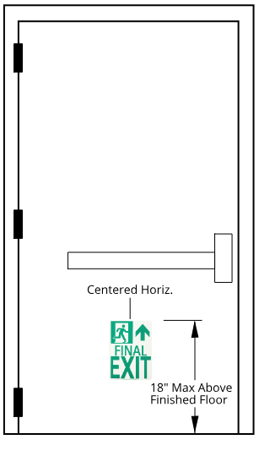
- Thoroughly clean the surface area where the sign will be installed with a dry cloth and a non‐residue cleaning compound to remove and loose particles and dirt. For oily surfaces, isopropyl alcohol works well for surface preparation. Seal porous surfaces if needed and repair cracks or damaged areas. Surfaces must be dry and dust free.
- Measure to determine proper location of the sign on the door or wall.
- The sign can be attached to the door or wall with the included adhesive tabs, appropriate construction adhesive applied to the back of the sign or with a mechanical fastener using the pre-drilled holes in each corner of the sign.
- When using the adhesive pads, peel the pad from the liner being careful not to touch the adhesive. Place the pads evenly to the back of the sign and press firmly into place. After the pads have been adhered to the back of the sign, remove the other liner from all the tabs, again being careful not to touch the adhesives. Place the sign in its appropriate location and press firmly to attach to the substrate. When using construction adhesive to attach the sign, follow the instruction provided by the manufacturer of the adhesive. When using mechanical fasteners to attach the sign be sure to use the proper type and length for the substrate.
Figure 1

Operation
- Exposure Requirements: The minimum amount of exposure to artificial ambient illumination is 60 minutes from the following:
    - One-foot candle (11 Lux) of florescent, incandescent or LED light
- The control of the ambient illumination necessary to charge the luminous egress-path-marking system should be restricted to authorized personnel only.
- Failure to supply the above minimum exposure can prevent the luminous egress-path-marking from performing as intended.
- No specific building surface treatment is required for the luminous egress-path-marking system to function properly.
- Reliable external illumination is required at all times during building occupancy.

- Maintain by cleaning as needed to prevent dirt, etc. from inhibiting the performance of the photoluminescent properties.
- The tape may be cleaned by using a damp cloth with mild, non‐abrasive cleaners. Do not us highly alkaline or acidic cleaners. Rinse after applying cleaners and wipe with a clean cotton cloth to dry.

Maintenance

Babcock-Davis warrants all Luminous Egress Products to be free from manufacturing defects in materials, factory finishes and workmanship from the date of shipment for a period of:

Standard Warranty
1 Year
Should a product fail to function in normal use within this period, Babcock-Davis shall furnish a replacement or new part at Nystrom’s discretion.
Failure to use product in methods consistent with Nystrom product manuals shall relieve Babcock-Davis of any liability.
Our liability under this warranty excludes installation or removal costs involved in the product replacement and excludes any responsibility for incidental or consequential damage of any nature.
Customer Actions for Claims on Product During Warranty Period
- Contact the Customer Service Department, Babcock-Davis, Brooklyn Park, MN, Telephone: 888.412.3726, to obtain a Return Material Authorization (RMA) number.
- You will be sent an “RMA” that is required to be filled out and returned with the shipment.
- The following information must appear on the outside of the package:
  - RMA number marked on the outside of box
- Return defective product FREIGHT PREPAID. Collect shipments will be refused.
- The factory will not process warranty claims until the customer has properly accomplished the above items.
- Babcock-Davis may accept the entire claim; part or none of the claim if our inspection of the returned parts proves the failure was for reasons other than defective material or factory workmanship.
Important Notes
- Babcock-Davis will not be responsible for damage incurred during the return shipment.
- All returns subject to inspection and a $50 evaluation fee
- This RMA is not authorization for credit. Credits and/or replacements will be issued upon evaluation of returned product.
- RMA is valid for thirty (30) days from issue date.

Factory Assistance
Babcock-Davis engineers and manufactures luminous egress products for worldwide customers. Our products enable safe exiting in egress stairways. Recognized as an industry leader, Babcock-Davis has been relied upon by building and construction professions for over 70 years and we pride ourselves in offering exceptional technical support.
Please do not return any product before discussing your application problem with a Babcock-Davis representative and obtaining a Return Authorization.
Your Babcock-Davis representative is eager to help you. Please feel free to call your representative or contact Babcock-Davis to discuss your application.
Babcock-Davis
9300 73rd Avenue North
Brooklyn Park, MN 55428

Phone: 888.412.3726
Fax: 888.312.3726
Email: info@babcockdavis.com

