Surface Mounted, Metal Corner Guard
Models: BCGSS, BCGTS and BCGAS

Important Notes:

- Locate the packing slip(s) and inspect all material for damages or missing parts. If products are damaged, notify the factory immediately and leave the products in their packaging. If products are signed and received without reporting damages, you waive your right to a freight claim and will be responsible for their replacement cost.
- Read the instructions thoroughly before beginning installation.
- All wall surfaces must be clean and dry.

Adhesive Mounting (Standard):

- Apply construction adhesive on back surface of both wings of the corner guard and along entire length.
- Position corner guard on wall corner and apply pressure along entire length of corner guard until secured to wall.
- If corner guard is not positioned directly on the floor or on the wall base, it is important to support the corner guard until the adhesive has set.
- Remove the protective covering from the face of the corner guard and clean surfaces using a damp cloth if necessary.

Mechanical Fastening (Optional):

- Position corner guard on wall surface.
- Attach corner guard using provided hardware thru the pre-drilled mounting holes.
- Remove the protective covering from the face of the corner guard and clean surfaces using a damp cloth if necessary.

Maintenance:

Pen marks, paint and graffiti generally wash off easily with mild soap and water. Be cautious with abrasive cleansers and scrub pads as they may scratch corner guards. Do not use steel wool or other metal scrub pads as fibers from the pads may stick to the corner guards and cause them to rust.

Plan View: Adhesive Mounting:
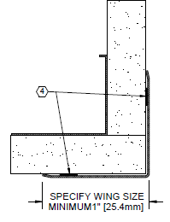 | 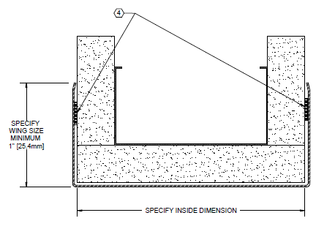
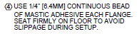

Plan View: Mechanical Fastening:
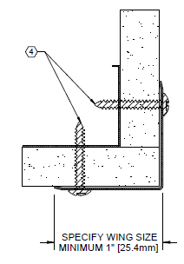 | 