Model(s): BFX, BFG
Surface Mount Aluminum Ramp

PREPARE FOR INSTALLATION
- Locate the packing slip(s) and shop drawings.
- Verify that all products listed on the packing slip are included in the package.
- Check the products for damage. If products are damaged, report a freight claim immediately and leave the products in their packaging. If you sign for products without reporting damage you waive your right to a freight claim and will be responsible for their replacement cost.
- Read the instructions thoroughly before beginning installation.
Installation
A flat floor and accurately installed frames are critical to the overall performance of the mat or grille.
- Verify the floor is flat and within 1/8 inch over 10 feet. Floor must be level to prevent damage to the mat/grille. If necessary, utilize a self-leveling compound (provided by others) to ensure a level floor surface.
- Position the frame members in the opening. Cut frames to fit opening.
- Frames are sent with drilled and countersunk 1/4 inch diameter holes. Mark and drill 1/4 inch holes in the floor for the anchors.
- Using the anchors provided, secure the frame to the floor.
Trim Mat
- Lay mat section(s) in the opening. The carpet strips must be perpendicular to the traffic direction.
- Mats should fit snug to the top and left side of opening.
- Trim the bottom and left side of mat. The mat should fit snug into frame.
Prep Mat
- Secure the mat retainers to each corner of the mat section; minimum of 4 retainers. Place the retainers approximately 2 rows from the side and 5 sets of pegs from the bottom. (Figure 1 and Figure 2)
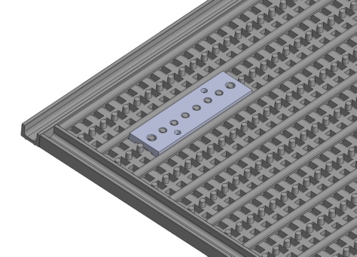
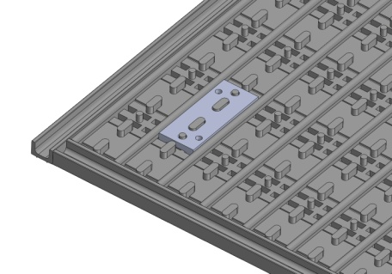
Figure 2
MAXgrid Retainer
Figure 1
MAXtread Retainer
Install Mat
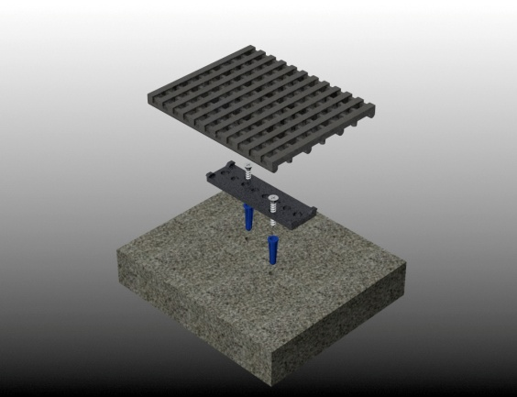
- Clean the recess thoroughly. Note: Debris not removed will cause irregularities in the recess that may cause a tripping hazard or the mat to rock.
- Set the trimmed mat(s) into the recess.
- Drill holes for the mat retainers using the retainer holes as a guide. Drill directly through the mat sections and retainer hole.
- Lift the mast sections and vacuum any dust.
- Secure the blue screw sleeves into the holes. A hammer with light pressure may be necessary. (Figure 3)
- Replace the mat sections.
- Drive the screws directly through the mat sections and retainers into the sleeves using a torque meter screw driver.
Figure 3

Maintenance
Continued maintenance is critical to the long term safety and performance of mats. Remove the mat and clean the recess periodically to prevent the surface from becoming uneven. Debris buildup within the recess could lead to deflection in the grille and may cause a tripping hazard.
Cleaning Treads
The type and schedule of maintenance of your mat will depend upon location and amount of traffic. Use the outline below for cleaning instructions for the variety of tread insert materials.
- A good heavy-duty vacuum cleaner with a rotating brush is the most effective way to routinely clean the carpet in your entrance mat or grille. By vibrating the fibers, this type of vacuum not only cleans the surface of the carpet, but also removes soil that is embedded into the pile. The rotating brush aids in keeping the pile upright for longer lasting beauty.
- The heaviest traffic areas should be vacuumed daily and the light traffic areas as infrequently as weekly.
- Carpet should be deep cleaned with a hot water extraction cleaner once per month or when vacuuming will no longer remove the soil. This depends upon soil and traffic conditions.
- Inspect the mat regularly for spots and stains to reduce the possibility of them becoming permanent.
Removing Spots
- If the spot is semi-solid, scrape with a spoon or spatula and then blot with a damp sponge. Work from the edge of the spot to the center. This will keep the stain from spreading. If this procedure does not work, use a spot remover.
- A dry system is recommended because it reduces solid build-up, will not leave the floor wet or slippery and no risk in damaging the carpet from dye bleeding. For most spills such as coffee, tea, or pet stains a dry soil extractor works best.
- Wet cleaning methods, including aerosols, foams, hot water extraction, or shampoo will work, but sometimes they leave sticky detergent residue that will accelerate soil buildup.
- For oily stains, such as tar, grease or paint, a non-flammable dry cleaning solvent works best. Be extremely careful when using dry cleaning solvent. Take care to check for color fastness before cleaning the entire surface. Put a few drops of stain remover in an inconspicuous area and press the area with a clean cloth for 10 seconds. If the color fades or changes discontinue use.

