Model(s): BFD

**Overview**

Floor Door products are designed and built for years of convenient and weather tight access for personnel as well as equipment. The following are general instructions for installing, operating and maintaining floor door products. These are recommended general guidelines only. Locally accepted installation, sealing practices and procedures should be followed to ensure the ultimate weather-ability of floor doors installed into various types of flooring systems.

**Set Up/Unpack**

fgasingleviews3*Warning: Floor Door is spring loaded. Do NOT open in upside down position*

* Orient the floor door in an upright position as shown.
* This is the correct position to handle the floor door.
* Visually inspect slam latch from the underside to ensure latch bolt is engaged over frame.
* fgasingleviews1Cut plastic tie wrap and remove envelope.

**Storage Prior to Installation**

Floor doors are shipped with the intent for installation within 30 days. If storage is required, insure the floor doors are stored covered and indoors. If stored outside, the floor door frames can expand and contract causing the protective epoxy coating to crack and chip. If this occurs, reapply an epoxy coating before installation.

**Installation for concrete pour in place**

1. Special care is required when handling and installing floor doors. Please make sure that all framework and doors are supported during transport and installation to insure against bending or racking of the floor door.
2. Floor door frames are provided with concrete anchors. Bend the anchors away from the frame at a 90 degree angle prior to installing the units.
3. Set the units into position over the desired opening area. The inside opening of the frame is the “opening size” (A 48 inch by 48 inch floor door has an inside opening of 48 inches by 48 inches). Secure the floor door into the desired area with welding, bolting or other anchorage, making sure not to interfere with the operation of the hatch.
4. 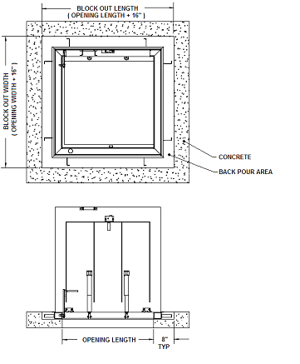For H20 off-street, infrequent vehicular traffic load rated floor doors, it is critical to include a sufficient C-channel support shelf as shown below.
5. To ensure a good quality installation and prevent staining, alkaline building materials such as wet concrete should be removed quickly from aluminum surfaces. We recommend providing a temporary protection such as a vinyl covering to protect finished surfaces during construction.
6. Pour concrete to the top edge of the frame, leveling to finish flush with the top of the flange of the floor door. Allow the concrete to cure for 7 days prior to operating the floor door. Operating the unit prior may crack the concrete.
7. After 7 days, open the door(s) and inspect the unit for excess concrete that may have seeped or fallen into the hinges, latch, gutter or other areas. Remove any concrete to ensure smooth operation.
8. 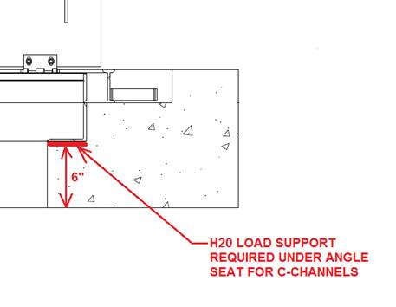At this point, you may have to adjust the spring packages with a 3/4 inch open end wrench. The springs have an adjustment bolt on the spring rod near the bottom of the spring housing. The springs may have been adjusted down to remove any undue stress on the frame during transport. Tighten the bolts until the tube is within 1/8 inch of the door bracket. *DO NOT OVER ADJUST*. Over adjusting will cause the spring to “bottom out” when closing the door. If the door does not close all the way, *DO NOT FORCE SHUT*. Adjust the springs down (more gap between the tube and door bracket). Try the door again and adjust springs again as necessary.
9. To install a spring to the floor door, simply insert the top of the spring through the door bracket then swing the bottom of the spring assembly towards the frame into the frame bracket and insert the 1/4-20 bolt through the frame bracket and spring rod and fasten with a 1/4-20 nylon nut.

**Spring installation**

1. 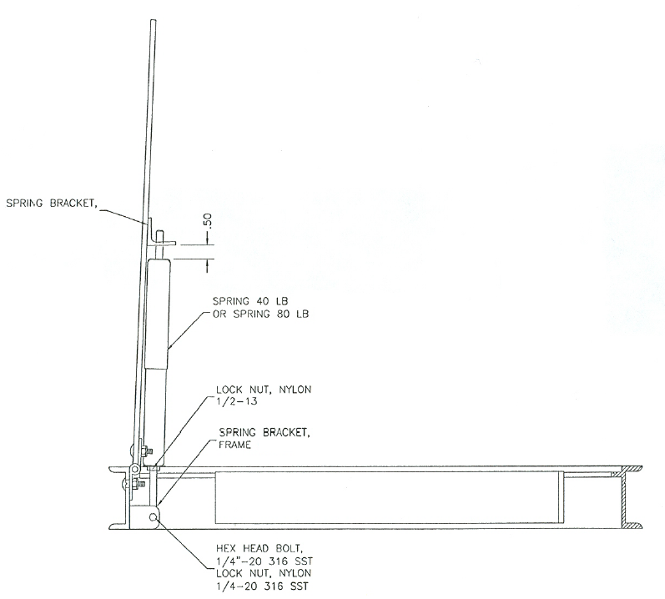Springs installed with the door in the open position, 90 degrees.
2. The larger diameter tube of the spring assembly will go up against the door bracket with the 1/2 inch diameter rod running through the bracket hole.
3. The other end of the rod is threaded and has a clearance hole. Line up the clearance hole in the rod with holes in the frame bracket. Make sure the rod is inside the clevis of frame bracket. Insert ¼” bolt and nut to secure spring to bracket on the frame.
4. Tighten up the 1/2 inch lock nut that is on the rod up against the bottom of the tube enclosure so there is a little gap between the top of the tube and the door bracket. Any additional tightening is considered applying preload.
5. Apply the same preload to all the spring on the door. This will require opening and closing the door to test. Adjust preload as required.
6. Due to the similarities of the two spring assemblies, check the correct spring assembly by counting the number of coils; 42 for the 40lb and 27 for the 80lb.

**Installation for bolt in place existing openings**

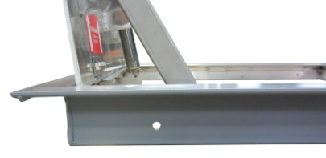The following are general instructions for installing, operating and maintaining floor door products intended for existing openings or bolt in place applications. These are recommended general guidelines only. Locally accepted installation, mounting, and sealing procedures should be followed to ensure the ultimate structural integrity of the installed floor doors.

FOR EXISTING OPENING FRAMES

2”x 3” FRAME WITH MOUNTING HOLES

1. Special care is required when handling and installing floor doors. Please make sure that all framework and doors are supported during transport and installation to insure against bending or racking of the floor door.
2. Floor doors for existing openings are provided with 3/8 inch diameter holes.

* For existing opening 2 inch by 3 inch frames, holes are provided through the frame
* For drainable frames, holes are provided in 2 inch by 2 inch angle tables
* For non-drainable frames, holes are provided in reinforcement blocks

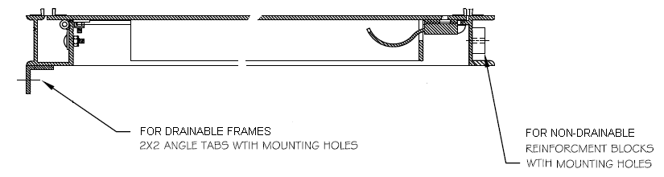

1. Set the floor door into position into the desired opening area and mark where fastener holes are located on the mounting surface. For existing concrete openings, 5/16 inch anchor bolts are recommended. For existing wood openings 5/16 inch lag bolts are recommended.
2. At this point, you may have to adjust the spring packages with a 3/4 inch open end wrench. The springs have an adjustment bolt on the spring rod near the bottom of the spring housing. The springs may have been adjusted down to remove any undue stress on the frame during transport. Tighten the bolts until the tube is within 1/8 inch of the door bracket. *DO NOT OVER ADJUST*. Over adjusting will cause the spring to “bottom out” when closing the door. If the door does not close all the way, *DO NOT FORCE SHUT*. Adjust the springs down (more gap between the tube and door bracket). Try the door again and adjust springs again as necessary.
3. To install a spring to the floor door, simply insert the top of the spring through the door bracket then swing the bottom of the spring assembly towards the frame into the frame bracket and insert the 1/4-20 bolt through the frame bracket and spring rod and fasten with a 1/4-20 nylon nut.

**Operation**

Floor doors are designed and built for years of dependable access. The floor doors are manufactured from steel, aluminum, and or stainless steel. All floor doors come standard with stainless steel hardware components. The basic components for door operation include turn handle latches, compression springs, stainless steel hinges and a locking hold open arm as detailed:

* **Latch:** Slam latch with interior rotating handle, and exterior L-handle key (FD-KIT-KEY)
* Drop down lifting handle
* **Spring:** Compression springs to ensure ease of opening and closing during use.
* **Hinge:** Stainless Steel hinges
* **Hold Open Arm:** Locking hold open arm automatically engages and locks when the door fully opens. The hold open arm must be engaged in the locked position to ensure that the door does not close unintentionally. Pull the red vinyl grip handle to unlock and safely close the door.

To open the floor door cover, use the slam latch L-handle key and rotate the slam latch. The cover will unlatch and spring open slightly. Use the lift handle from the top of the cover to fully pull open the door(s) until the hold open arm engages to lock the cover in the 90 degree open position.

To close the floor door cover, pull the red grip handle on the hold open arm forward to disengage and gently lower the cover. Slam the door slightly to ensure proper latch engagement. For double doors be sure to close the door with the slam latch last.

**Maintenance**

* Floor doors should be manually operated once a year to check performance.
* Lubricate moving parts such as springs, hinges, and latches with a silicone spray lube as required to maintain a smooth opening and closing of the door. Do not over grease. Do not use regular lubricating oil as it can attract dust and grit.
* Non-moving parts can be cleaned with a mild soap or dishwashing detergent and water solution.
* Gaskets can be cleaned with a clean, damp, lint-free cloth. Do not apply mineral oils, vinyl dressings, or other lubricants to the gasket as they can cause the gasket to break down over time.
* If any questions arise during the operation or maintenance of the products, please feel free to call technical assistance, 1-888-312-3726.

Follow the maintenance instructions to ensure the long life of the product. Contact Babcock-Davis for information on replacing damaged parts.