Model(s): BFL10LBM
Prepare for Installation
- Locate the packing slip(s) and shop drawings.
- Verify that all products listed on the packing slip are included in the package.
- Check the products for damage. If products are damaged, report a freight claim immediately and leave the products in their packaging. If you sign for products without reporting damage you waive your right to a freight claim and will be responsible for their replacement cost.
- Read the instructions thoroughly before beginning installation.
Prepare the Recess
A flat recess and accurately installed frames are critical to the overall performance of the Grille. Utilize a self-leveling compound (provide by others) if necessary to ensure a level recess,
- The rough opening for the frame should be at least 3” deep and at least the width and length of the frame. This allows room to maneuver the frame and provides clearance for the anchor bolts.
- Verify that the bottom of the recess is flat within 1/8 inch over 10’. The recess must be flat to prevent damage to the mat / Grille. Utilize a self-leveling compound (provide by others) if necessary to ensure a level floor surface.
Assemble the Frames
Frames that exceed 96 inch in either width or traffic direction are shipped in separate pieces.
- Assemble the frame sections according to the shop drawings. Splice plates and pins are provided for connecting frame pieces together.
  - Cross supports are attached to the perimeter frame with the 1/4-20 by 1 inch self-threading screws through the pre-punched holes in the perimeter frame and into the screw bosses on the cross support sections.
  - Cross support is spliced together using splice pins.
  - Perimeter frame is spliced together using splice plate
- Make sure that the frame is plumb, that corner conditions are joined at the correct angles, and that it is at the correct height. Also, check the measurements of the frame against the shop drawings in several locations to make sure that the sizes are correct. The grille will not fit if the frame is not installed as indicated on the shop drawings.
Illustration 1
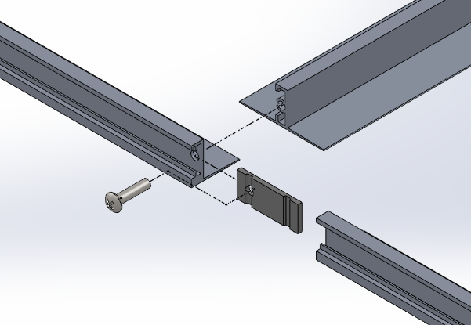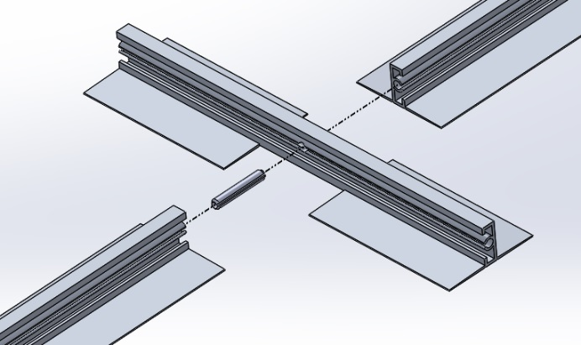

Install the Frame

- Thoroughly sweep the substrate to remove all dirt and debris.
- Place the assembled frame into the opening. Shim as necessary to level the frame to the final height of the finished floor surface.
- Mark the fastening point locations on the frames. The required locations are indicated on the shop drawings. Otherwise, evenly space the fastening points at a maximum distance of 24 inch on all sides of the frame. Drill and countersink 1/4 inch diameter holes at the marked locations.
- Mark and drill 1/4 inch diameter holes in the floor for the anchors.
- Line the frame members up with the holes and securely fasten the frame to the floor with the provided anchors.

Install the Grille
- Remove the plywood or other filler from the recess and clean the recess thoroughly. Note that debris will cause irregularities in the recess that may cause the Grille to rock or create a tripping hazard.
- Consult drawings to determine the correct locations of the Grille sections. Note that Grilles with notches, angle cuts or radius cuts, must be in the proper location, with all sections facing the same direction. Set Grilles into the recess.
- Save the installation and maintenance instructions and include them with the closeout documentation for the owner and maintenance personnel.

maintenance
Continued maintenance is critical to the long-term safety and performance of the mat / grille. Remove the mat / grille and clean the recess periodically to prevent the surface from becoming uneven. Debris build up within the recess could lead to deflection in the grille and may possibly cause tripping hazards.
The type and schedule of maintenance of your grille or mat will depend upon location and amount of traffic. See the outline below for cleaning instructions for the variety of tread insert materials.
Aluminum Mats and Grilles
- Clean the treads with a vacuum or broom first, and then mop the treads with standard floor cleaner.
Follow the tread maintenance instructions to ensure the long life of the Grille tread. Contact Babcock-Davis for information on replacing damaged treads.

