Model(s): BFL10LBC

Prepare for Installation
- Locate the packing slip(s) and shop drawings.
- Verify that all products listed on the packing slip are included in the package.
- Check the products for damage. If products are damaged, report a freight claim immediately and leave the products in their packaging. If you sign for products without reporting damage you waive your right to a freight claim and will be responsible for their replacement cost.
- Read the instructions thoroughly before beginning installation.
Prepare the Recess
A flat recess and accurately installed frames are critical to the overall performance of the Grille. Utilize a self-leveling compound (provide by others) if necessary to ensure a level recess,
- The rough opening for the frame should be at least 3 inch deep and at least the width and length of the frame. This allows room to maneuver the frame and provides clearance for the anchor bolts.
- Verify that the bottom of the recess is flat within 1/8 inch over 10’. The recess must be flat to prevent damage to the mat / Grille. Utilize a self-leveling compound (provide by others) if necessary to ensure a level floor surface.

Assemble the Frames
Frames that exceed 96 inch in either width or traffic direction are shipped in separate pieces.
- Assemble the frame sections according to the shop drawings. Splice plates and pins are provided for connecting frame pieces together.
  - Cross supports are attached to the perimeter frame using the 1/4-20 by 1 inch self-threading screws.
  - Cross support is spliced together using splice pins.
  - Perimeter frame is spliced together using splice plate
- Insert the 1/4 inch by 2 inch anchor bolts, hex nut and wing nuts at the pre-drilled holes on the bottom leg of the frame
- Make sure that the frame is plumb, that corner conditions are joined at the correct angles, and that it is at the correct height. Also, check the measurements of the frame against the shop drawings in several locations to make sure that the sizes are correct. The grille will not fit if the frame is not installed as indicated on the shop drawings.
Illustration 1
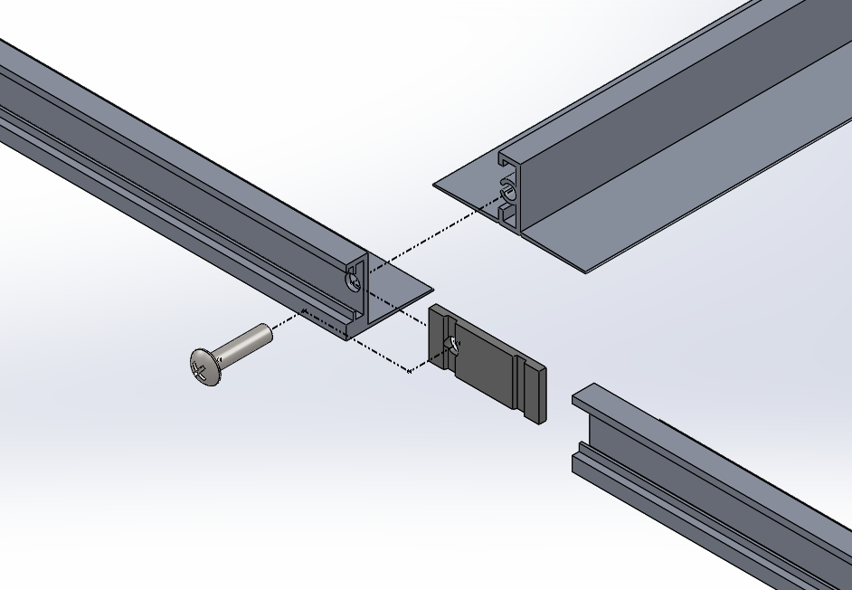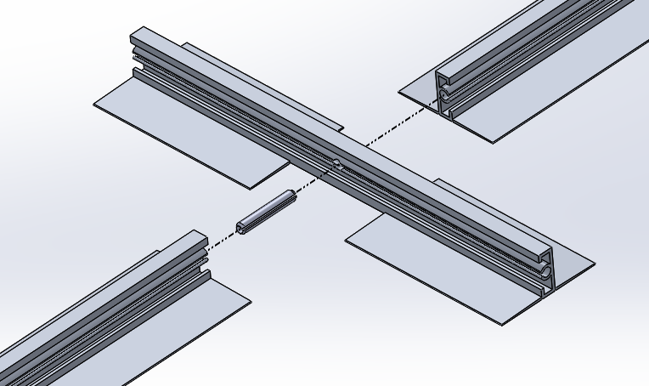
Install the Frame

- Place the assembled frame into the opening. Shim as necessary to level the frame to the final height of the finished floor surface.
- Pour cement mortar around the edges of the frame and the center in sufficient quantity to be level with the inside lip of the frame.
- With a board that is slightly shorter than the inside of the frame, smooth and level the mortar. It is critical that the recess be absolutely flat within 1/8 inch over 10’ and at the correct height to prevent damage to the product.
- Before the mortar sets, check the frame to make sure that it is plumb, that the members join at the correct angles, and that it is at the correct height. Also, check the measurements of the frame against the shop drawings in several locations to make sure that the sizes are correct. The mat / Grille will not fit if the frame is not installed exactly as indicated on the shop drawings. Use spreaders if necessary to hold the frame at the correct dimensions.
- After the mortar has set, lay the optional drain pan material (if applicable) in the bottom of the recess. Caulk all edges and seams.
- When the cement has hardened, install plywood or other material in the recess to protect the edges of the frame until it is time to install the Grilles. Wait to install the mats / Grilles until the building is ready for use.
INSTALL THE DRAIN PAN (Optional)
- Use a caulk gun to apply adhesive to the recessed surface medium.
- Place pre-cut drain pan sheets into recess. Apply pressure to all areas of the pan to aid in bonding.
- Apply a silicone Caulk to all drain pan seams: Where pan meets frame and where pan sections abut.
Install the Grille
- Thoroughly sweep the substrate to remove all dirt and debris.
- Remove the plywood or other filler from the recess and clean the recess thoroughly. Note that debris will cause irregularities in the recess that may cause the Grille to rock or create a tripping hazard.
- Consult drawings to determine the correct locations of the Grille sections. Note that Grilles with notches, angle cuts or radius cuts, must be in the proper location, with all sections facing the same direction. Set Grilles into the recess.
- Save the installation and maintenance instructions and include them with the closeout documentation for the owner and maintenance personnel.
maintenance
Continued maintenance is critical to the long-term safety and performance of the mat / Grille. Remove the mat / Grille and clean the recess periodically to prevent the surface from becoming uneven. Debris build up within the recess could lead to deflection in the Grille and may possibly cause tripping hazards.
The type and schedule of maintenance of your Grille or mat will depend upon location and amount of traffic. See the outline below for cleaning instructions for the variety of tread insert materials.
Aluminum Mats and Grilles
- Clean the treads with a vacuum or broom first, and then mop the treads with standard floor cleaner.
Follow the tread maintenance instructions to ensure the long life of the Grille tread. Contact Babcock-Davis for information on replacing damaged treads.

