Model(s): Select, Vision, Vanguard, Crown

Non-Rated
Non-Rated Extinguisher Cabinets can be installed in either metal or wood stud walls. All framing dimensions must correspond with the dimensions indicated on our submittals.
- Framing must be on all four (4) sides of the cabinet. Where load bearing studs are cut, a load bearing header or frame out must be installed above the cabinet to maintain the load bearing integrity of the wall.
- Position the cabinet in the wall, verifying that the backside of the cabinet frame is flush against the wall surface.
- Drill 5/32 inch diameter holes at least every 12 inches on each side of the cabinet through the tub wall and continue drilling through the studs.
- Secure cabinet into the wall studs by installing #12 by 2 inch self-drilling mounting screws.
Fire-Rated
Fire Rated Extinguisher Cabinets can be installed in either metal or wood stud walls. All framing dimensions must correspond with the dimensions indicated on our submittals.
- Framing must be on all four (4) sides of the cabinet. Where load bearing studs are cut, a load bearing header or frame out must be installed above the cabinet to maintain the load bearing integrity of the wall.
- Position the cabinet in the wall, verifying that the backside of the cabinet frame is flush against the wall surface.
- Drill 5/32 inch diameter holes at least every 12 inches on each side of the cabinet through the double tub construction and continue drilling through the studs.
- Secure cabinet into the wall studs by installing #12 by 2 inch self-drilling mounting screws.
break-rite glass installation/replacment
CAUTION: Safety glasses and gloves should be worn when working with glass.
- Open cabinet door completely.
- While holding glass in right hand, position lower left-hand corner of glass in bottom center of door.
- With Break Rite® handle in left hand, reach around the exterior of the door and position handle on center left edge of glass.
- Holding handle and glass slide both into position in the door.
- While holding glass and handle in place, insert the (4) spring glass clips into the slot provided. For hose and valve cabinets, use screw and glass clips as provided.
- Close and lock cabinet door.
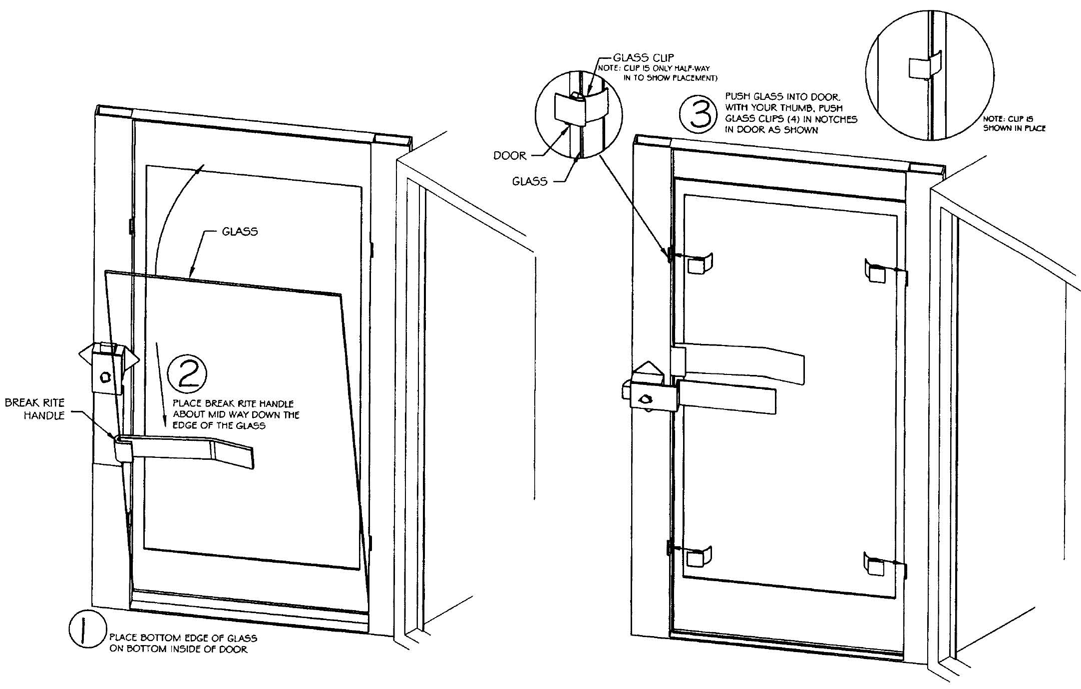maintenance
Follow instructions to ensure the long life of the fire extinguisher cabinet. Contact Babcock-Davis for information on replacing damaged parts.

