Model(s): NW, EW

Overview
Access Doors are designed and built for years of convenient and easy access to mechanical areas in commercial buildings.
The following is a general instruction for installing, operating and maintaining Architectural and Renovation wall bead frame doors. These are recommended general guidelines only. Locally accepted practices and procedures should be followed to ensure the ultimate durability of access door installed into the various different types of construction.
Installation
Wall or ceiling opening is door size plus 1/4 inch. Example: 12 inch by 12 inch door, opening should be 12-1/4 inch by 12-1/4 inches.
- Place the door into the opening. Flange should seat firmly against wall/ceiling surface.
- Install drywall screws through face of flange into the wall (Figure 1).
- The screw head should be below the flange for a smooth bead application (Figure 1).
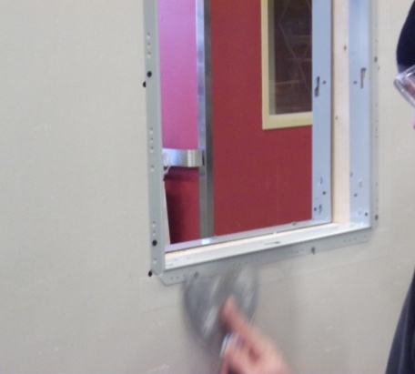
- Tape and mud as required (Figure 2).
Figure 2
Figure 1
Operation
Access doors are designed and built for years of dependable wall and ceiling access. Our access doors come standard with white baked on powder coat finish that offers the best corrosion protection in the industry.
The basic components for door operation include latching and locking mechanism and the button snap hinges:
- Latch: Screw driver operated cam latch for easy access
- Button snap hinge: Quickly and easily remove doors using the finger operated button snap hinges (Figure 3).
Figure 3
Maintenance
- Access doors should be manually operated once a year to check performance.
- Lubricate moving parts such as hinges and latches with a silicone spray lube as required to maintain a smooth opening and closing of the door. Do not over grease. Do not use regular lubricating oil as it can attract dust and grit.
- Non-moving parts can be cleaned with a mild soap or dishwashing detergent and water solution.
- Gaskets can be cleaned with a clean, damp, lint-free cloth. Do not apply mineral oils, vinyl dressings, or other lubricants to the gasket as they can cause the gasket to break down over time.
- If any questions arise during the operation or maintenance of the products, please feel free to call for technical support.

