Model(s): BFDWT
Overview
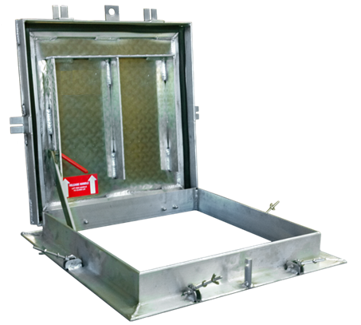
Watertight floor door products are designed and built and used in well hatch applications. The following are general instructions for installing, operating and maintaining these floor door products. Watertight floor doors are tested to a 10ft column of water, 625psf live load. Continuous cover gasket and exterior pressure locks ensure its watertight performance.
These are recommended general guidelines only. Locally accepted installation, mounting, and sealing procedures should be followed to ensure the ultimate weather-ability and structural integrity of the floor doors installed into various types of flooring systems.
Storage Prior to Installation
Do not store floor door outside. If storage is required, insure the floor doors properly covered and stored indoors.
Installation
- Special care is required when handling and installing floor doors. Please make sure that all framework and doors are supported during transport and installation to insure against bending or racking of the floor door.
- Set the units into position over the desired opening area. The inside opening of the frame is the “opening” Secure the floor door into the desired area with welding, bolting or other anchorage, making sure not to interfere with the operation of the hatch.
- Watertight floor doors are designed to be surface mounted in the field. The frame mounting holes are drilled in the field. The mounting hardware and under gasket seals are provided by others, in the field.
- Drill clearance holes through the aluminum frame flange that are appropriately sized according to the bolts or concrete anchors used. (ie. 5/16 inch, 3/8 inch or 1/2 inch, or other as field conditions require.) Mounting hardware is not provided by manufacturer.
- Position floor door over opening and mark where fastener holes are located on the mounting surface. Prepare concrete as required. Install gasket seal/caulk under frame, as required for watertight installation

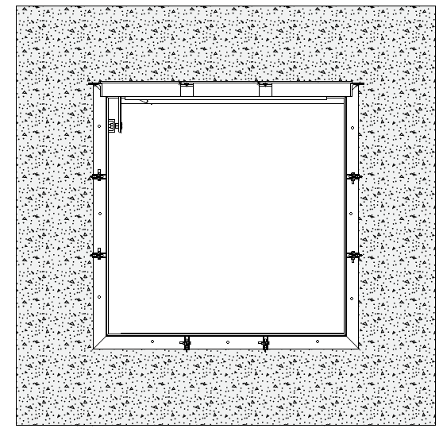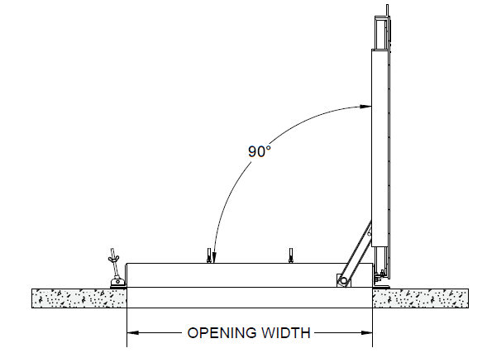
Frame mounting holes are drilled in the field. Spacing shown here for reference.
Gasket seal/caulk under frame flange, provided by others in the field.

Operation
Floor doors are designed and built for years of dependable access. The floor doors are manufactured from steel, aluminum, and or stainless steel. All floor doors come standard with stainless steel hardware components. The basic components for door operation include turn handle latches, compression springs, stainless steel hinges and a locking hold open arm as detailed:
- Pressure locks latches with wing nuts
- Heavy duty butt hinges
- Hold Open Arm automatically engages and locks when the door fully opens. The hold open arm must be engaged in the locked position to ensure that the door does not close unintentionally. Pull the red vinyl grip handle to unlock and safely close the door.
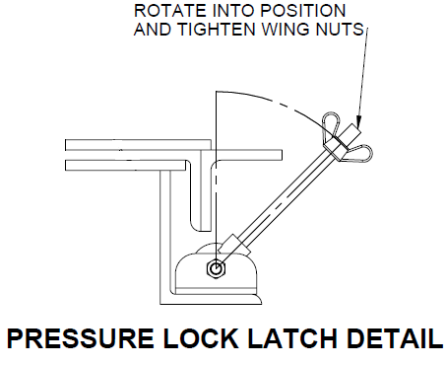
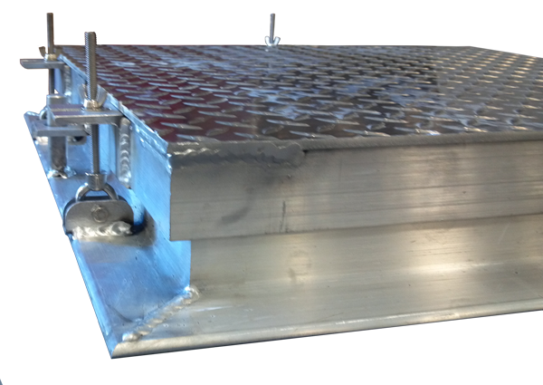
To open the floor door cover, unscrew the wing nuts from pressure lock latch until there is sufficient clearance for the latch to rotate down away from the cover catch. Repeat this process for all pressure lock latches located around the entire perimeter of the floor door.
Fully open the door until the hold open arm engages to lock the cover in the 90 degree open position.
To close the floor door cover, pull the red grip handle on the hold open arm forward to disengage and gently lower the cover.
Re-install each pressure lock latch by rotating back into position and screwing wing nut to secure door in position. Final tighten all wing nuts to ensure watertight seal.
Maintenance
- Floor doors should be manually operated once a year to check performance.
- Lubricate moving parts such as hinges and latches with a silicone spray lube as required to maintain a smooth opening and closing of the door. Do not over grease. Do not use regular lubricating oil as it can attract dust and grit.
- Non-moving parts can be cleaned with a mild soap or dishwashing detergent and water solution.
- Gaskets can be cleaned with a clean, damp, lint-free cloth. Do not apply mineral oils, vinyl dressings, or other lubricants to the gasket as they can cause the gasket to break down over time.
- If any questions arise during the operation or maintenance of the products, please feel free to call toll-free number for assistance 1-888-412-3726.
Follow the maintenance instructions to ensure the long life of the product. Contact Nystrom for information on replacing damaged parts.

