Model(s): BFA10D2C
Prepare for Installation
- Locate the packing slip(s) and shop drawings.
- Verify that all products listed on the packing slip are included in the package.
- Check the products for damage. If products are damaged, report a freight claim immediately and leave the products in their packaging. If you sign for products without reporting damage you waive your right to a freight claim and will be responsible for their replacement cost.
- Read the instructions thoroughly before beginning installation.
Prepare the Recess
A flat recess and accurately installed frames are critical to the overall performance of the grille. Utilize a self-leveling compound (provide by others) if necessary to ensure a level recess,
- The recess for the frame should be at least 1/2 inch deeper than the total height of your grille, frame and drain pan.
- Block out an area at least 4 inches wider than the outside dimensions of the frame in both directions.
Assemble the Frames
Frames that exceed 96 inches in either width or traffic direction are shipped in separate pieces.
- Assemble the frame sections according to the shop drawings. If frames are provided in sections, they will be split at the cross supports and reconnected by bolting a left and right cross support together. Bolts are provided for connecting frame cross supports. Insert the 1/4 inch by 1/2 inch self-threading bolts though the pre-drilled holes in the cross-support sections as shown on the illustration below.
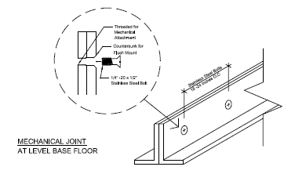
Illustration 1
Install the Frame
- Thoroughly sweep the substrate to remove all dirt and debris.
- Place the assembled frame into the opening. Shim as necessary to level the frame to the final height of the finished floor surface.
- Pour cement mortar around the edges of the frame and the center in sufficient quantity to be level with the inside lip of the frame.
- With a board that is slightly shorter than the inside of the frame, smooth and level the mortar. It is critical that the recess be flat within 1/8 inch over 10 feet and at the correct height to prevent damage to the product.
- Before the mortar sets, check the frame to make sure that it is plumb, that the members join at the correct angles, and that it is at the correct height. Also, check the measurements of the frame against the shop drawings in several locations to make sure that the sizes are correct. The mat / grille will not fit if the frame is not installed exactly as indicated on the shop drawings. Use spreaders if necessary to hold the frame at the correct dimensions.
- After the mortar has set, lay the optional drain pan material (if applicable) in the bottom of the recess. Caulk all edges and seams.
- When the cement has hardened, install plywood or other material in the recess to protect the edges of the frame until it is time to install the grilles. Wait to install the mats / grilles until the building is ready for use.
Install the Grille
- Remove the plywood or other filler from the recess and clean the recess thoroughly. Note that debris will cause irregularities in the recess that may cause the grille to rock or create a tripping hazard.
- Consult drawings to determine the correct locations of the grille sections. Note that grilles with notches, angle cuts or radius cuts, must be in the proper location, with all sections facing the same direction. Set grilles into the recess.
- Save the installation and maintenance instructions and include them with the closeout documentation for the owner and maintenance personnel.
- Hidden lock-down clips are optional. If clips are included, locate the clips, one on each corner of each grille section. Drill 1/4 inch diameter by 3/4 inch deep holes into concrete through each clip. Insert the screws provided into each hole and tighten.
Illustrations 2-5
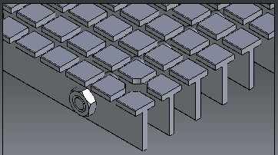
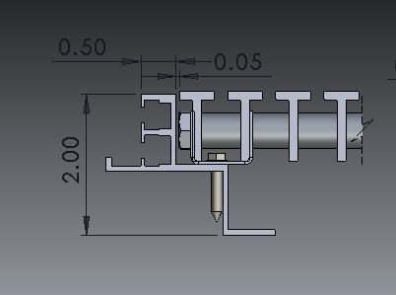
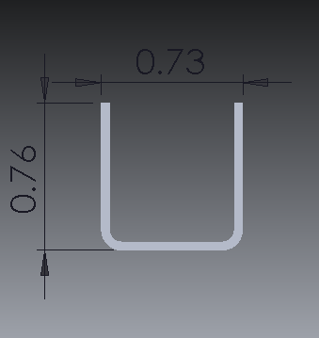
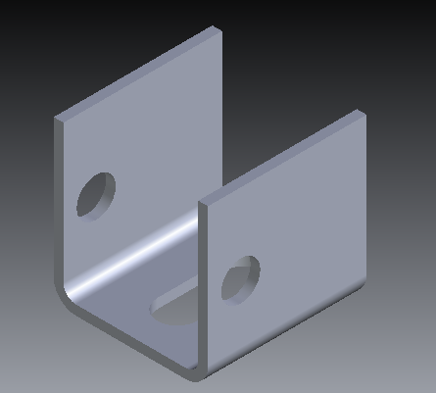

maintenance
Continued maintenance is critical to the long-term safety and performance of the mat / grille. Remove the mat / grille and clean the recess periodically to prevent the surface from becoming uneven. Debris build up within the recess could lead to deflection in the grille and may possibly cause tripping hazards.
The type and schedule of maintenance of your grille or mat will depend upon location and amount of traffic. See the outline below for cleaning instructions for the variety of tread insert materials.
Aluminum Mats and Grilles
- Clean the treads with a vacuum or broom first, and then mop the treads with standard floor cleaner.
Follow the tread maintenance instructions to ensure the long life of the grille tread. Contact Babcock-Davis for information on replacing damaged treads.

