Lume-A-Lite™ Marking Strip
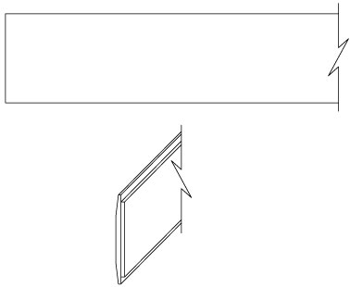
INSTALLATION, OPERATION + MAINTENANCE MANUAL
Model(s): BEM-DS1

Table of Contents

Table of Contents
General Description 3
Installation 4-6
Operation 7
Maintenance 8
Standard Warranty 9
Factory Assistance 10

Copyright
2019 by Babcock-Davis. All rights reserved.

This document contains proprietary information. No part of this document may be reproduced without the prior written consent of Babcock-Davis.

Note
The information in this document is subject to change without notice.

General Safety Precautions
Improper selection, installation, or use can cause personal injury or property damage. It is solely the responsibility of the user, through its own analysis to select products suitable for their specific application requirements, ensure they are properly maintained, and limit their use to its intended purpose.

Follow proper local, state and federal regulations for proper installation and operation requirements.

General Description
Photoluminescent egress path marking systems are an important life safety requirement in current building codes. These systems allow for the safe and quick evacuation of buildings in the case of an emergency. They provide a routing system that is not dependent on electrical power that can easily be followed in dark and smoke-filled exit pathways.
The following is a general instruction for installing, operating and maintaining egress path marking systems. These are general guidelines only.
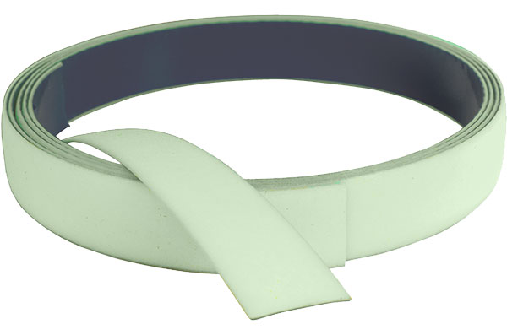
Preparation

Installation
Please read the complete instructions carefully before beginning any work.
- The temperature of the product being installed and the surface it is being installed on must be at least 60 degrees.
- Surfaces must be clean, smooth and non-porous. Install a sample piece of the strip material for 24 hours on the application surface to ensure that the strip adheres properly before doing a complete project installation.
- Gloves should be used when handling and installing the strip to prevent injury.
Note: These are finished products and need to be stored in a clean and dry location. Strips have a shelf life of up to nine months from the date of shipment.
Perimeter Demarcation – Wall Mounted
Installation
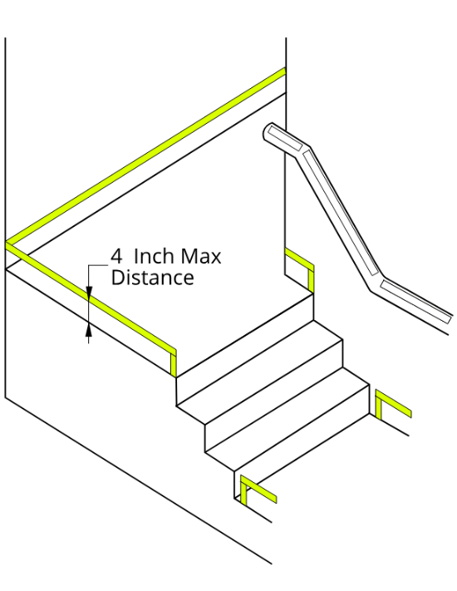
Solid and continuous photoluminescent strips are to be installed on the walls of stair landings and other floor areas within interior exit stairways, interior exit ramps and exit passageways, except for the sides of steps (figure 1). Interruptions in the strips shall not exceed four (4) inches. The strips shall be placed on the walls with the bottom edge not being more than four (4) inches above the finished floor. At the top or bottom of the stairs, the strip shall drop vertically to the floor within two (2) inches of the step or landing edge. The strip on walls shall transition vertically to the floor and then extend across the floor where a line on the floor is the only practical method of outlining the path. Where the wall line is broken by a door, the strips on walls shall continue across the face of the door or transition to the floor and extend across the floor in front of such door with the exception of exit discharge doors, that lead out of an exit and through which occupants must travel to complete the exit path.
- Thoroughly clean the surface area where the strip will be installed with a dry cloth and non‐residue cleaning compound to remove and loose particles and dirt. For oily surfaces, isopropyl alcohol works well for surface preparation. Seal porous surfaces and repair cracks or damaged areas. Surface must be dry and dust free.
- Measure to determine the proper length of the strip needed and then cut with scissors.
- Peel the backing from the strip without touching the adhesive.
Figure 1
- Place the strip and starting from one end to the other, firmly press the strip onto the wall. Make sure the strip is straight and its bottom edge is within 4 inches of the finished floor. Be sure that the strip is in full contact with the wall, this may involve using a rubber roller to ensure proper adhesion.

Installation
Perimeter Demarcation – Floor Mounted
Installation
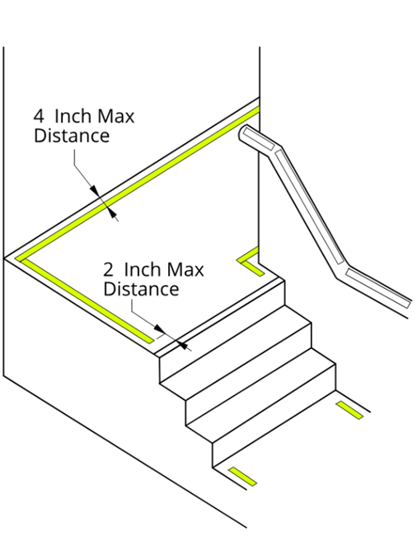
Solid and continuous photoluminescent strips are to be installed on the floor areas within interior exit stairways, interior exit ramps and exit passageways, except for the sides of steps. Interruptions in the strips shall not exceed 4 inches. The strips shall be placed within 4 inches of the wall and shall extend to within 2 inches of the markings on the leading edge of the landings. The strips shall continue across the floor in front of all doors except for exit discharge doors, that lead out of an exit and through which occupants must travel to complete the exit path (figure 2).
- Thoroughly clean the surface area where the strip will be installed. Vacuum or sweep area and with a dry cloth and non‐residue cleaning compound clean the application area. For oily surfaces, isopropyl alcohol works well for surface preparation. Seal porous surfaces and repair cracks or damaged areas. Surface must be dry and dust free.
- Measure to determine the proper length of the strip needed and then cut with scissors.
- Peel the backing from the strip without touching the adhesive.
- Place the strip and starting from one end to the other, firmly press the strip onto the wall. Make sure the strip is straight and its bottom edge is within 4 inches of the finished floor. Be sure that the strip is in full contact with the wall, this may involve using a rubber roller to ensure proper adhesion.
Figure 2
Exit Door – Hardware Markings
Installation
Where a panic bar or push bar is installed, photoluminescent strip shall be installed the entire length of the actuating bar or touchpad (figure 3).
- Thoroughly clean the surface area where the strip will be installed with a dry cloth and non‐residue cleaning compound to remove and loose particles and dirt. For oily surfaces, isopropyl alcohol works well for surface preparation. Seal porous surfaces and repair cracks or damaged areas. Surface must be dry and dust free.
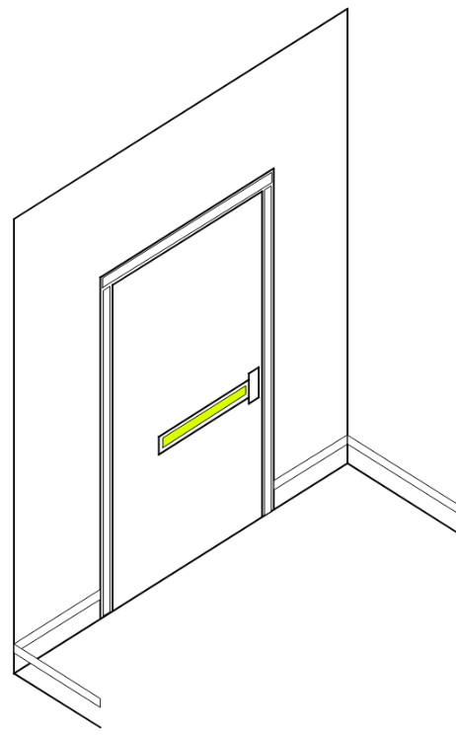
- Measure the size of the strip that is needed to cover the entire length of the push bar.
- When installing the strip to the push bar, peel the backing from the strip without touching the adhesive. Place the strip and starting from one end to the other, firmly press the strip onto the bar. Make sure the strip is straight and aligned correctly. Be sure that the strip is in full contact with the bar, this may involve using a rubber roller to ensure proper adhesion.

Exit Door – Frame Markings
Installation
Figure 3
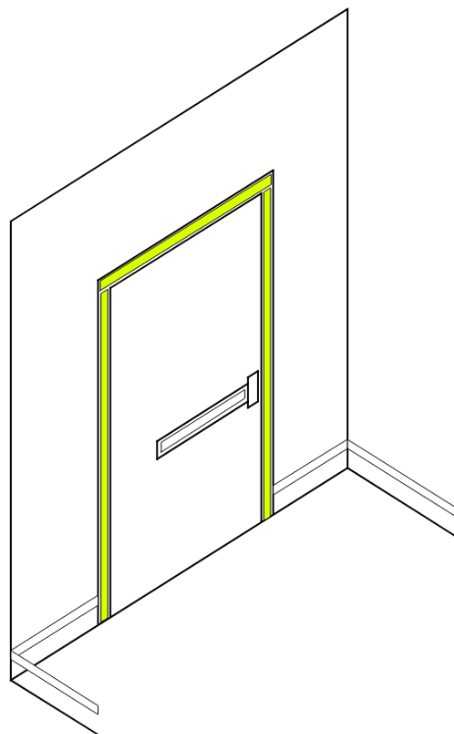
The top and sides of the door frame shall be marked with a solid and continuous photoluminescent strips. Where the door molding does not provide a sufficiently flat surface on which to locate the strip, they shall be installed on the wall surrounding the frame (figure 4).
- Thoroughly clean the surface area where the strip will be installed with a dry cloth and non‐residue cleaning compound to remove and loose particles and dirt. For oily surfaces, isopropyl alcohol works well for surface preparation. Seal porous surfaces and repair cracks or damaged areas. Surface must be dry and dust free.
- Measure to determine the proper length of the strip needed and then cut with scissors.
- Peel the backing from the strip without touching the adhesive.
- Place the strip and starting from one end to the other, firmly press the strip onto the door frame or wall. Make sure the strip is straight and aligned correctly. Be sure that the strip is in full contact with the door frame or wall, this may involve using a rubber roller to ensure proper adhesion.
Figure 4

Installation

Operation
- Exposure Requirements: The minimum amount of exposure to artificial ambient illumination is 60 minutes from the following:
    - One-foot candle (11 Lux) of florescent, incandescent or LED light
- The control of the ambient illumination necessary to charge the luminous egress-path-marking system should be restricted to authorized personnel only.
- Failure to supply the above minimum exposure can prevent the luminous egress-path-marking from performing as intended.
- No specific building surface treatment is required for the luminous egress-path-marking system to function properly.
- Reliable external illumination is required at all times during building occupancy.

- Maintain by cleaning as needed to prevent dirt, etc. from inhibiting the performance of the photoluminescent properties.
- The strip may be cleaned by using a damp cloth with mild, non‐abrasive cleaners. Do not us highly alkaline or acidic cleaners. Rinse after applying cleaners and wipe with a clean cotton cloth to dry.

Maintenance

Babcock-Davis warrants all Luminous Egress Products to be free from manufacturing defects in materials, factory finishes and workmanship from the date of shipment for a period of:

Standard Warranty
1 Year
Should a product fail to function in normal use within this period, Babcock-Davis shall furnish a replacement or new part at Nystrom’s discretion.
Failure to use product in methods consistent with Nystrom product manuals shall relieve Babcock-Davis of any liability.
Our liability under this warranty excludes installation or removal costs involved in the product replacement and excludes any responsibility for incidental or consequential damage of any nature.
Customer Actions for Claims on Product During Warranty Period
- Contact the Customer Service Department, Babcock-Davis, Brooklyn Park, MN, Telephone: 888.412.3726, to obtain a Return Material Authorization (RMA) number.
- You will be sent an “RMA” that is required to be filled out and returned with the shipment.
- The following information must appear on the outside of the package:
  - RMA number marked on the outside of box
- Return defective product FREIGHT PREPAID. Collect shipments will be refused.
- The factory will not process warranty claims until the customer has properly accomplished the above items.
- Babcock-Davis may accept the entire claim; part or none of the claim if our inspection of the returned parts proves the failure was for reasons other than defective material or factory workmanship.
Important Notes
- Babcock-Davis will not be responsible for damage incurred during the return shipment.
- All returns subject to inspection and a $50 evaluation fee
- This RMA is not authorization for credit. Credits and/or replacements will be issued upon evaluation of returned product.
- RMA is valid for thirty (30) days from issue date.

Factory Assistance
Babcock-Davis engineers and manufactures luminous egress products for worldwide customers. Our products enable safe exiting in egress stairways. Recognized as an industry leader, Babcock-Davis has been relied upon by building and construction professions for over 70 years and we pride ourselves in offering exceptional technical support.
Please do not return any product before discussing your application problem with a Babcock-Davis representative and obtaining a Return Authorization.
Your Babcock-Davis representative is eager to help you. Please feel free to call your representative or contact Babcock-Davis to discuss your application.
Babcock-Davis
9300 73rd Avenue North
Brooklyn Park, MN 55428

Phone: 888.412.3726
Fax: 888.312.3726
Email: info@babcockdavis.com

