Vinyl Bumper Guard
Models: BBGVS35C

Important Notes:

- Locate and install Crash Rail in accordance with architectural drawings and specifications. When required, shop drawings should be used in conjunction with these documents
- Locate the packing slip(s) and inspect all material for damages or missing parts. If products are damaged, notify the factory immediately and leave the products in their packaging. If products are signed and received without reporting damages, you waive your right to a freight claim and will be responsible for their replacement cost.
- Store material in a clean, dry location at room temperature between 65° F (18° C) and 77° F (25° C) for at least 24 hours prior cutting and installing to minimize expansion and contraction of materials.
- Read the instructions thoroughly before beginning installation.

Vinyl Bumper Guard
- Snap a chalk line at the proper location on the wall to ensure a level installation. Chalk line should be calculated to the centerline of the mounting bracket wall fasteners.
- Place the retainer in the proper location and fasten to wall with proper fasteners (not included).
- Attach the ends to the retainer. Drill and pop-rivet in place.
Note: Prior to installation of the cover, make sure that all fasteners are secure and properly seated.
- Hold the cover at an angle and place the top of the cover behind the top of the retainer. Make sure that the cover is placed in the proper position and snap-fit the cover onto the aluminum retainer by placing hands downward and applying pressure with the heel of each hand to force the cover onto the retainer. Continue along until the complete length of the cover is securely installed.
Note: Cover Material is provided in 20’-0” stock lengths to be cut in the field. An 80-100 tooth, carbide tip saw blade or equivalent is recommended for cutting the material to minimize chipping. It is recommended that the cover be cut slightly oversize to provide proper alignment between the end caps.
- If you have any questions during installation, please call your local Babcock-Davis representative.
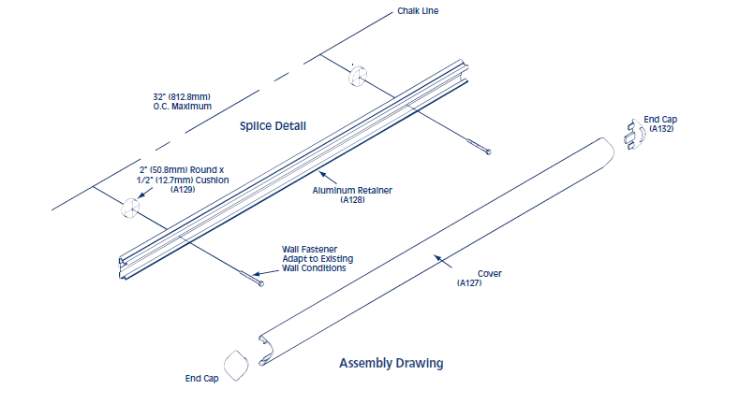
Installation Dimensions for BBGVS35C-C125 (1/8” mounting cushion), BBGVS35C-C05 (1/2” mounting cushion), BBGVE35C-B15 (1 ½’” mounting bracket) and BBGVE35C-B2 (2” mounting bracket).

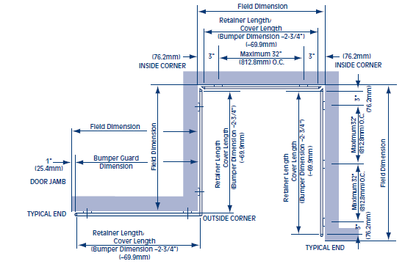
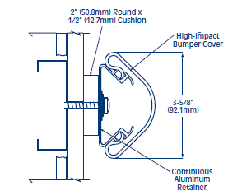 | 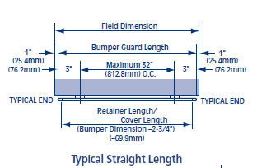 | 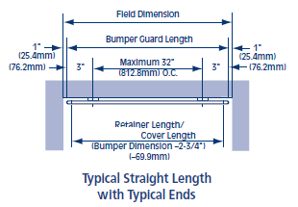

Maintenance:
- Use mild detergent to clean soiled surfaces. Pen marks, paint and graffiti generally wash off easily with mild soap and water. Completely rinse the surface with clean water when complete.
Note: Powdered cleansers and bleach cleaners should be used with care as they may leave a residue embedded in the cover surface. Properly rinsing with clean water will remove any residual residue.
- Tough marks or stains may require a heavy duty cleaner such as “Crown Anti-Vandal Spray” or “DWR-II”. These specialized spot cleaners should only be used on small areas and tested for color fastness prior to applying in a highly visible area. Rinse thoroughly with clean water to remove the residue from these cleaners

