September 1, 2015
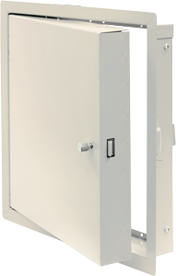
RE: Standard Powder Coat Color Change
In response to market demand, Babcock-Davis announces a shift from gray to white doors with a lower sheen finish. Expect to start seeing these arrive towards the end of the year.
- Warehouse inventory will be turned over to white as orders are processed.
- For a period of time, orders will ship with a mix of gray and white.
- Gray doors will have a gray dot on the box for identification.
- Please indicate at time of order if all one color is required.
- Orders for gray doors placed after January 1, 2016 will be custom.
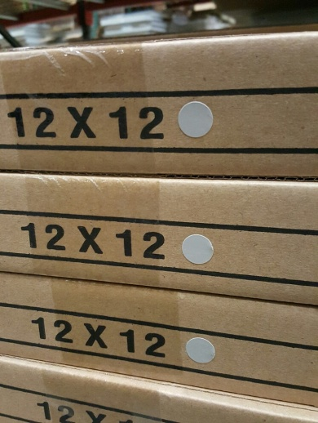
For additional questions or concerns, please contact your Account Manager. We appreciate the opportunity to service you.
Dalen DeFoe
Product Manager

